**SIMPLE DESIGN DOCUMENT**

1. Plus Function
2. Interface

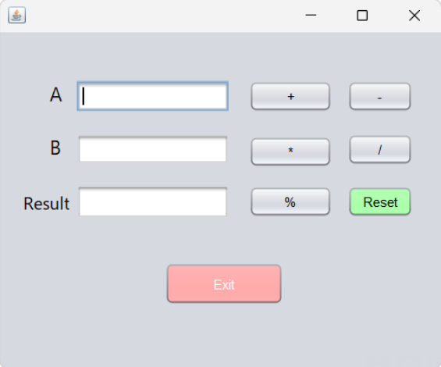

1. Usecase

| Use Case ID: UC01 | | | |
| --- | --- | --- | --- |
| Use Case Name: Plus | | | |
| Member Create: Le Thanh Nhat Minh, Le Trung Dung | | Member Last Update: Le Thanh Nhat Minh, Le Trung Dung | |
| Date Create: 26/01/2024 | | | |
| Actor: User | | | |
| Describes: This use case describes function produces the plus results of 2 numbers a,b | | | |
| Pre-conditions: | | Enter A, B | |
| Post-conditions: | |  | |
| Priority: H/M/L | | High | |
| Use frequency: | | Low | |
| Standard processes: | | | |
| Step | Actor Action | | System Response |
| 1 | Run application | | The application run successful |
| 2 | Input number A in textfield A, number B in textfield B | | - If A is not A number the Result label display “A must a number”  - If B is not a number the Result label display “B must a number” |
| 3 | Click on “+” button | | The result will display on textfield Result |

1. Subtract Function
   1. Interface



* 1. Usecase

| Use Case ID: UC02 | | | |
| --- | --- | --- | --- |
| Use Case Name: Subtraction | | | |
| Member Create: Le Thanh Nhat Minh, Le Trung Dung | | Member Last Update: Le Thanh Nhat Minh, Le Trung Dung | |
| Date Create: 26/01/2024 | | | |
| Actor: User | | | |
| Describes: This use case describes function produces the subtract results of 2 numbers a,b | | | |
| Pre-conditions: | | Enter A, B | |
| Post-conditions: | |  | |
| Priority: H/M/L | | High | |
| Use frequency: | | Low | |
| Standard processes: | | | |
| Step | Actor Action | | System Response |
| 1 | Run application | | The application run successful |
| 2 | Input number A in textfield A, number B in textfield B | | - If A is not a number the Result label display “A must a number”  - If B is not a number the Result label display “B must a number” |
| 3 | Click on “-“ button | | The result will display on textfield Result |

1. Multiply Function
   1. Interface



* 1. Usecase

| Use Case ID: UC03 | | | |
| --- | --- | --- | --- |
| Use Case Name: Multiplication | | | |
| Member Create: Le Thanh Nhat Minh, Le Trung Dung | | Member Last Update: Le Thanh Nhat Minh, Le Trung Dung | |
| Date Create: 26/01/2024 | | | |
| Actor: User | | | |
| Describes: This use case describes function produces the multiply results of 2 numbers a,b | | | |
| Pre-conditions: | | Enter A, B | |
| Post-conditions: | |  | |
| Priority: H/M/L | | High | |
| Use frequency: | | Low | |
| Standard processes: | | | |
| Step | Actor Action | | System Response |
| 1 | Run application | | The application run successful |
| 2 | Input A, B in textfield and click Multiply button | | - If A is not a number the Result label display “A must a number”  - If B is not a number the Result label display “B must a number” |
| 3 | Click “*” function | | The result will display on textfield Result |

1. Divide Function
   1. Interface



1. Usecase

| Use Case ID: UC04 | | | |
| --- | --- | --- | --- |
| Use Case Name: Division | | | |
| Member Create: Le Thanh Nhat Minh, Le Trung Dung | | Member Last Update: Le Thanh Nhat Minh, Le Trung Dung | |
| Date Create: 26/01/2024 | | | |
| Actor: User | | | |
| Describes: This use case describes function produces the divide results of 2 numbers a,b | | | |
| Pre-conditions: | | Enter a, b | |
| Post-conditions: | |  | |
| Priority: H/M/L | | High | |
| Use frequency: | | Low | |
| Standard processes: | | | |
| Step | Actor Action | | System Response |
| 1 | Run application | | The application run successful |
| 2 | Input A, B in textfield and click Divide button | | - If A is not a number the Result label display “A must a number”  - If B is not a number the Result label display “B must a number” |
| 3 | Click “/” button | | The result will display on textfield Result |

1. Modulo Function
   1. Interface



* 1. Usecase

| Use Case ID: UC05 | | | |
| --- | --- | --- | --- |
| Use Case Name: Modulo | | | |
| Member Create: Le Thanh Nhat Minh, Le Trung Dung | | Member Last Update: Le Thanh Nhat Minh, Le Trung Dung | |
| Date Create: 26/01/2024 | | | |
| Actor: User | | | |
| Describes: This use case describes function produces the remainder of the division results of 2 numbers a,b | | | |
| Pre-conditions: | | Enter a, b | |
| Post-conditions: | |  | |
| Priority: H/M/L | | High | |
| Use frequency: | | Low | |
| Standard processes: | | | |
| Step | Actor Action | | System Response |
| 1 | Run application | | The application run successful |
| 2 | Input A, B in textfield and click Modulo button | | - If A is not a number the Result label display “A must a number”  - If B is not a number the Result label display “B must a number” |
| 3 | Click “%” button | | The result will display on textfield Result |

1. Reset Function
   1. Interface



* 1. Usecase

| Use Case ID: UC06 | | | |
| --- | --- | --- | --- |
| Use Case Name: Reset | | | |
| Member Create: Le Thanh Nhat Minh, Le Trung Dung | | Member Last Update: Le Thanh Nhat Minh, Le Trung Dung | |
| Date Create: 26/01/2024 | | | |
| Actor: User | | | |
| Describes: This use case describes function will reset 2 number a, b to their initial value | | | |
| Pre-conditions: | | Enter a, b | |
| Post-conditions: | |  | |
| Priority: H/M/L | | High | |
| Use frequency: | | Low | |
| Standard processes: | | | |
| Step | Actor Action | | System Response |
| 1 | Run application | | The application run successful |
| 2 | Click “Reset” button | | Text field A, text field B and text field result will reset |

1. Exit Function
   1. Interface



* 1. Usecase

| Use Case ID: UC07 | | | |
| --- | --- | --- | --- |
| Use Case Name: Exit | | | |
| Member Create: Le Thanh Nhat Minh, Le Trung Dung | | Member Last Update: Le Thanh Nhat Minh, Le Trung Dung | |
| Date Create: 26/01/2024 | | | |
| Actor: User | | | |
| Describes: This use case describes function will exit | | | |
| Pre-conditions: | |  | |
| Post-conditions: | |  | |
| Priority: H/M/L | | High | |
| Use frequency: | | Low | |
| Standard processes: | | | |
| Step | Actor Action | | System Response |
| 1 | Run application | | The application run successful |
| 3 | Click “Exit” button | | The system will shut down program |